USDA Foreign Agricultural Service
GAIN Report

Global Agriculture Information Network
Template Version 2.09

Required Report - public distribution
Date: 11/6/2006
GAIN Report Number: PE6022
PE6022
Peru
Exporter Guide
Annual
2006

Approved by:
Eugene Philhower
U.S. Embassy
Prepared by:
Violeta Gutierrez

Report Highlights:
Peru's economy is one of the most vibrant in Latin America today. The U.S. - Peru Trade Promotion Agreement (TPA), pending U.S. Congressional approval will offer duty preferences for U.S. exporters of high-value products such as meats, cheeses, snacks, fresh fruits, prepared fruits and vegetables, pet foods and food ingredients. This report summarizes key trade and market conditions to help U.S. importers make the most of the U.S. - Peru TPA opportunities.

Includes PSD Changes: No
Includes Trade Matrix: No
Annual Report
Lima [PE1]
[PE]
Table of Contents

Section I. Market Overview Page 3 of 13
Section II. Exporter Business Tips Page 4 of 13
Section III. Market Sector Structure and Trends Page 6 of 13
Section IV. Best High-Value Product Prospects Page 7 of 13
Section V. Key Contacts and Further Information Page 10 of 13
Table A. Key Trade & Demographic Information
Table B. Consumer Food & Edible Fishery Product Imports
Table C. Top 15 Suppliers of Consumer Foods & Edible Fishery Products
Section I. Market Overview
Over the past decade, Peru has been transformed by market-oriented economic reforms and privatizations and has met many of the conditions for long-term growth. Peru’s economy is one of the most vibrant in Latin America. In 2005, Gross Domestic Product (GDP) reached $78.4 billion, growing an estimated 6.4 percent, and 6.8 percent in the first three months of 2006. GDP growth was driven by construction, mining, foreign investment, domestic demand and exports.
Domestic Economy | 2003 | 2004 | 2005
Nominal GDP (U.S. $ billions) | 60 | 67 | 78.4
Real GDP Growth (%) | 3.8 | 4.5 | 6.4
GDP per capita (nominal U.S. $) | 2,212 | 2,518 | 2,591
Ave. annual exchange rate (new soles/$) | 3.5 | 3.3 | 3.3
Inflation (Dec. to Dec. %) | 2.5 | 3.5 | 1.7
Central Govt. Spending (% GDP) | 16.4 | 15.3 | 15
Foreign Exchange Reserves ($millions) | 10,194 | 12,631 | 15,000

Source: Central Reserve Bank of Peru, www.bcrp.gob.pe (2003-2005)

In 2005, total food sales were estimated at $5 billion. Total consumer-oriented food imports reached $339 million, growing 17 percent over 2004. The U.S. was the fourth largest supplier ($30 million), with nine percent of market share, facing stiff competition from Chile (25 percent), Colombia and Argentina (12 and 13 percent respectively). Food imports are distributed among a number of sectors, with 56 percent directed towards the retail sector, and 24 and 20 percent directed towards the food processing and the food service sectors, respectively.

U.S. exports to Peru in terms of total sales have traditionally been bulk commodities - wheat, coarse grains and cotton with wheat accounting for approximately 50 percent of sales. From 2004 to 2005, total U.S. exports for agricultural, fish and forestry products declined 29 percent due to a sharp decrease in wheat sales. However, sales of U.S. consumer-oriented products increased by 21 percent.

The U.S. – Peru Trade Promotion Agreement (TPA), pending U.S. Congressional approval, should be implemented on January 1, 2007. The U.S. – Peru TPA will immediately provide duty free access for two-thirds of U.S. food and agricultural products, including high-quality beef, cotton, wheat, soybeans, soybean meal and crude soybean oil; key fruits and vegetables (including apples, pears, peaches, cherries and almonds); food ingredients and many processed food products including frozen french fries, cookies and snack foods. Tariffs on most remaining U.S. farm products will be phased out within 15 years, with all tariffs eliminated in 17 years.

Lima is the major market for consumer-oriented foods with almost one third of Peru’s total population and more than 60 percent of the national income. In 2005, high and middle-income consumers, the main market for U.S. food sales, reached around 1.8 million inhabitants, with a monthly family income of $1,120 on average. Middle-low income consumers account for 2.7 million people, but constitute an important source for future
expansion. Unemployment in Lima has increased in recent months to 9 percent, from 8.5 percent in 2005, while underemployment accounts for more than 56 percent.

Advantages and Challenges Facing U.S. Products in Peru

Advantages | Challenges
- Upcoming U.S.- Peru TPA will grant duty free access to two-thirds of U.S. food and agricultural products.  - Open market for previously banned products (beef, offals, poultry, pork)  - Growing food processing and HRI sectors that will demand more food ingredients.  - Proactive supermarket industry that will result in increased demand for high-value products.  - Increased tourism creates new opportunities for food service development.  - Fast food chains expanding in major cities.  - Appreciation for U.S. food quality and culture.  - People are becoming aware of diet, lite and healthy food products through media. | - Peru is negotiating trade agreements with other countries, which could lessen competitive advantage of the U.S.  - Consumer habits, Peruvians prefer meals based on fresh products and spicy seasonings.  - Lack of brand awareness among consumers.  - New local food brands appearing in the market at very low prices.  - Relatively small market due to limited purchasing power; 76 percent of Peruvian population are low-income consumers.  - Supermarkets, the main source of imported food products, account for only 24 percent of total retail food sales in Lima.  - Government campaign called “Buy Peruvian” to encourage purchase of local products.  - Smuggling.

Section II. Exporter Business Tips

- Two-thirds of U.S. food and agricultural products will be exported to Peru duty free immediately. The complete list of products that will be benefited from the U.S. – Peru TPA can be found at:

http://www.ustr.gov/Trade_Agreements/Bilateral/Peru_TPA/Section_Index.html

- Imported food products have tariff rates that range between 12 and 25 percent. These tariffs will decrease or be eliminated as soon as the U.S.- Peru TPA is implemented.

- All imports are subject to a 19 percent local sales tax. Wine and liquors are assessed an additional selective consumer tax (ISC) of 20 percent; water and sodas, 17 percent and beer, 27.8 percent.

- For further information on food standards and regulations, labeling and import procedures please refer to our latest Food and Agricultural Import Regulation and Standards Report PE6014.

- Food standards and regulations

Sanitary inspection, food registration, packaging and control regulations for food and beverages are included in the Supreme Decree No. 007-98-SA of September 25, 1998. The General Environmental Health Bureau (DIGESA), within the Ministry of Health, is the Peruvian counterpart to the Food and Drug Administration (FDA) regarding sanitary supervision and registration of food and beverages. The National Agricultural Sanitary and Phytosanitary Service (SENASA), part of the Ministry of Agriculture, is the local counterpart to the U.S. Department of Agriculture (USDA) concerning the development of sanitary and phytosanitary regulations and the inspection of animal and plant origin products. The National Institute for the Defense of Competition and for the Protection of Intellectual Property (INDECOPI) is the agency in charge of labeling standards, labeling control and trademarks.

- General import and inspection procedures

In order to clear Customs (SUNAT) imports must have a Unique Customs Declaration (DUA), a commercial invoice, an airway bill or bill of lading, a packing list, an insurance letter and a food sanitary registry for food processed products from DIGESA or a health certificate for animals, plants or their by-products complying with SENASA’s import requirements.

Once the customs agent transmits the DUA electronically, SUNAT will determine the type of control for the merchandise within the following channels: green, orange and red. Channel green permits delivery of the product once duties are paid; channel orange requires review of the documentation and channel red requires review of the documentation and physical inspection.

- Food and beverage sanitary registration

The importer needs to submit a sworn application to DIGESA (available at www.digesa.sld.pe) accompanied by a certificate of free trade and use, the future label and the registration receipt ($69 approximately). If the certificate is not available, the importer should present a document issued by the Peruvian Consulate in the country of origin. The sworn application includes the contact information of the importer’s company and the manufacturer, his tax payer’s identification (R.U.C.), the list of products requested and for each product the content, results of physical-chemical and microbiological analysis, lot code system, expiration date, packing material and storage conditions.

This procedure will take no more than seven working days. The Sanitary Registration will be valid for five years from the date of issue and may be renewed between seven and sixty working days before the expiration date.

- Certificates for animals, plants and their by-products

Before the product is shipped, the importer must request an import permit from SENASA ($25 approximately). The exporter must provide to the importer the corresponding official health certificate of the country of origin, including the specific certification requirements of SENASA.

USDA agencies that issue health certificates for Peru are the Animal and Plant Health Inspection Service (APHIS) for animals and plants and their derived products, the Food
Safety and Inspection Service (FSIS) for meats and their by-products and the Agricultural Marketing Service (AMS) for U.S. dairy products.

- Labeling requirements

Imported packaged foods must carry a separate adhesive label before reaching the point of sale with a Spanish translation of the label including the importer/distributor’s contact information and R.U.C. Law 28405 of November 30, 2004 requires labeling for value-added products other than foods (which could be included in the future). Imported value-added products that do not comply with the provisions of this law, will require to be properly label in private storages for customs clearance.

Section III. Market Sector Structure and Trends

- In order to enter the Peruvian food market, U.S. exporters should contact local food processing companies, importers/wholesalers/distributors directly or indirectly through brokers, agents or representatives.

- Regardless of which strategy is chosen, personal visits are highly recommended. The local partner should be well known by the U.S. company before any permanent contractual arrangement is made.

- The local partner should be able to provide updated information on market consumer trends, current market development (merchandising, point of sales and promotion activities) and trade business practices.

- Food Service Sector

In 2005, total food service sales accounted for approximately $190 millions, considering only the formal sector. More than 60 percent of this amount corresponded to high-end food service. Growth remains steady at five percent in the last three years. In 2005, total food service imports were estimated at $68 million, 36 percent of total food service sales.

The niche market for U.S. exporters in this sector includes high-end hotels and restaurants, family style restaurants, fast food chains and coffee shops. Fast food chains present the fastest annual growth with approximately eight percent in the last five years. The main international food franchises represented in Peru are KFC, McDonalds, Pizza Hut, Chili’s, Domino’s Pizza and Burger King. The local owned Bembos leads the fast food sales with half of the hamburger market ($14 million).

International tourist arrivals have grown 7 percent annually in the last five years. In 2004, 1.3 million tourists spent $1 billion during their visit. In addition, two million local tourists traveled within the country, creating demand for food services. Along with tourism growth, new investments in lodging of the international hotel chains ACCOR, Meliá, Casa Andina, Ramada, Orient Express and Marriott are expected.

Products for the food service that will be benefited from the U.S. – Peru TPA with lower or duty free tariffs include food ingredients, fruits, cheeses, processed fruits and vegetables, meats and specialties.

- Food Processing Sector

In 2005, total food processing sector sales were estimated at $3.2 billion of which $81 million were imported. Annual growth of this sector for total sales is estimated at four percent and for food imports at three percent.

Food processors are concentrated in 86 companies, which represent 75 percent of total sales. Local food-processing companies include Alicorp (dairy, snacks, food ingredients, sauces, pasta), Gloria and Laive (dairy products), San Fernando and Avinka (poultry meat and by-products), Industrias Añaños (sodas), Montana (food ingredients) and Destilería Peruana (alcoholic beverages).

Major prospects for the U.S. in the food processing sector include food ingredients for the dairy, flavorings and baked goods industry.

- Food Retail Sector

In 2005, the total food retail market was estimated at $5 billion, of which 80 percent is concentrated in Lima. Supermarket chains surpassed $1 billion in food sales, growing 12 percent on average in the last four years. They represent 24 percent of the market share in Lima and 20 percent nationwide.

Wong and Supermercados Peruanos, both Peruvian companies, are the two major supermarket chains. Tottus Hypermarkets is the newest one. Wong and Supermercados Peruanos hold 60 percent and 28 percent of the supermarket market share, respectively (Apoyo Consulting Group).

Supermarkets are expanding quickly to peripheral areas around Lima, which offer significant potential for increased sales. These fast growing areas are constituted by low-income families, mostly concerned about price, and quite indifferent to brand names and quality concerns.

Wong and Supermercados Peruanos are also developing strategies to keep their position in the high-end sector by renovating and re-opening existing high-end stores. Wong modernized its logo and is selling their customers the idea of better service with fair prices. Supermercados Peruanos is gradually re-opening its existing “Santa Isabel” stores offering a different brand and a more modern layout with supermarkets called “Vivanda” and hypermarkets called “Plaza Vea”.

The target market for supermarkets in Lima is divided into two groups: high and middle-income families with an average income per month of $1,000 and around 1.6 million inhabitants and low income families whose average income per month is $250 representing around 6.3 million inhabitants.

Five percent of the consumer-oriented products sold in supermarkets are imported. Although they are particularly sensitive to economic conditions, there is potential for U.S. food exports in snacks, fruit and vegetable juices, fresh fruits (especially pears, apples and grapes), canned fruits and vegetables, dairy products (especially cheeses), wines and liquors and pet foods.

Section IV. Best High-Value Product Prospects

- Peru gives tariff preferences to the Andean Community (Bolivia, Colombia, Ecuador and Venezuela), and to Mexico, Paraguay, Argentina, Brazil, Uruguay and Cuba.
- Peru’s trade policy is oriented to open markets. Peru has signed an Economic Complementation Agreement (ECA) with MERCOSUR, a major U.S. competitor in bulk commodities and meats, exempting dairy products from the negotiations. Peru recently expanded its ECA with Chile, Peru’s major supplier of food and agricultural goods and has begun talks for an ECA with Mexico. Peru is a member of the Andean Community of Nations (CAN), which is seeking a free trade agreement with the E.U. Peru is also negotiating a free trade agreement with Thailand.

- Neighboring countries and especially Chile, Colombia, Argentina and Brazil are major food exporters to Peru. Chile and Colombia benefit from lower transport costs. Argentina is exporting to Peru with competitive prices due to the devaluation of the Argentine peso in 2002.

- The U.S. – Peru TPA will reinforce U.S. competitiveness within the Peruvian market. The quality of U.S. products is already appreciated among the high-end consumers.

Product Category | Market Size 2006 est. | Imports 2006 est. | 2002-2006  Avg. Annual Import Growth | Import Tariff Rate | Key Constraints over Market Development | Market Attractiveness for the U.S.
Other food prepara-tions  (HS 2106) | N/A | 11,705 MT  ($67 million) | 13.5% (recovering) | 12% | - Major competitors are neighbors: Chile (29%) and Colombia (25%). | - Access under TPA: duty free.  - U.S. is the third supplier with 14% of market share.  - The market (food service and food processing sectors) is open to new products such as protein concentrates and preparations for beverages.
Snack foods | $36 million* (extruded and fried, confectionary is not included) | 17,586 MT  ($41.2million) | 9.2%  (grow-ing) | 25% | - Major suppliers are neighbor countries Colombia (32%), Chile (22%) and Ecuador (7%). | - Access under TPA: duty free for major U.S. exports (confectionary, cookies, prepared potatoes); other products will enter 3 to 5 years linear.  - Market with potential growth in HRI and Retail.  - U.S. quality is appreciated.
Fruits and vegetables processed | N/A | 45,903 TM  ($40 million) | 9% (growth is slowing down) | 25% | - Chile is the major competitor (48%) due to low prices.  - Netherlands and the U.S. account for 10% each. | - Access under TPA: duty free for major U.S. exports (French frozen fries, soups and their preparations, mayonnaise); other products will enter 3 to 5 years linear.  - Consumer preferences especially for U.S. soups and sauces.  - U.S. exports are expected to grow 30% in 2006.
Red Meats fresh, chilled, frozen | 165,300 MT  ($12 million) | 25,531 TM  ($33 million) | 13.3%  (recovering) | 25% | - Major suppliers are big beef producers for the region: Argentina (46%), Brazil (21%) and Paraguay (19%). | - Access under TPA: duty free for prime beef, duty free for a quota of 800 TM for standard quality beef and 10,000 TM for beef offals.

Product Category | Market Size 2006 est. | Imports 2006 est. | 2002-2006  Avg. Annual Import Growth | Import Tariff Rate | Key Constraints over Market Development | Market Attractiveness for the U.S.
Fresh fruits | 3,700 MT | 50,119 MT  ($28 million) | 15%  (grow-ing) | 25% | - Chilean imports come duty free.  - Chile keeps 98% of imports and the U.S. 1.7%. | - U.S. exports in a window different from Chile.  - U.S. pears and recently grapes are imported for the high-end market.
Wine and Beer | 11.6 million liters (wine)  464 million liters (beer) | 32 million liters  ($16 million) | 10.5%  (fluctuating) | 17% | - Major exporters of wine are Argentina (28.4%) and Chile (26%) and of beer is Brazil (21%).  - Strong promotions from competitors.  - Only regular wine consumers recognize U.S. wine quality. | - Access under TPA: duty free for beer and five years linear for wine.  - There is a niche market for quality wines on which the U.S. can be appreciated and price competitive according to future benefits from the TPA.  - Post promotes U.S. wines taking advantage of the growing market for cheeses targeting the high-end sector.  - Per capita annual wine consumption is growing, 1 liter for wine and 30 liters for beer.
Pet foods | 40,000 MT | 15,040 MT  ($11 million) | 16% | 12% | - Growing local pet industry.  - There is an informal industry arising. | - Access under TPA: duty free, or 5 years linear for canned pet food.
Poultry meat | $1,000 million | 10,871 MT  ($8 million) | 13.1%  (Rising) | 25% | - Strong local poultry industry, imports are mainly poultry offals. | - Access under TPA: quota of 12,000 MT for chicken leg quarters, two years linear for mechanically de-boned chicken meat and five years linear for poultry offals.  - Peruvians are major consumers of poultry.
Whey  (HS 0404) | 7,386 MT  ($8 million) | 7,386 MT  ($8 million) | 28.6%  (slow-ing slightly) | 25% | - Major competitors are France (18%) and Chile (13%), which is growing market share.  - Included in price band. | - U.S. is the major supplier with 22.5% of market share.  - Growing market: multiple uses in the food industry.
Lactose | 1,276 MT  ($1 million) | 1,276 MT  ($1 million) | 48.8%  (slow-ing down) | 4% | - The industry imports low amounts from Germany and Netherlands. | - Access under TPA: duty free.  - The U.S. supplies almost 100% of imported lactose.

Section V. Key Contacts and Further Information

If you have any question or comments regarding this report or need assistance exporting to Peru, please contact the Foreign Agricultural Service in Lima at the following address:

U.S. Embassy Lima, Foreign Agricultural Service (FAS)
Mailing Address: Office of Agricultural Affairs, Unit 3785, APO AA 34031
Address: Av. La Encalada cdra. 17, Monterrico, Lima 33
Phone: (511) 434-3042
Fax: (511) 434-3043
E-mail: Aglima@usda.gov

For further information, check the FAS web site www.fas.usda.gov or our web site www.usdaperu.org.pe. Please, also refer to our other current food market related reports: Food Processing Ingredients Sector, Retail Food Sector and HRI Food Service Sector and Food and Agricultural Import Regulations and Standards (FAIRS) and FAIRS Export Certificate reports.

Trade Associations

American Chamber of Commerce of Peru (AMCHAM)
Executive Director: Aldo Defilippi
Address: Av. Ricardo Palma 836, Miraflores - Lima 18
Phone: (511) 241-0708 / 705-8000
Fax: (511) 241-0709
Web site: www.amcham.org.pe
E-mail: amcham@amcham.org.pe

National Society of Industries (SNI)
President: George Schofield
Address: Los Laureles 365, San Isidro - Lima 27
Phone: (511) 421-8830
Fax: (511) 442-2570
Web site: www.sni.org.pe

Hotel and Restaurant Association (AHORA)
President: Adolfo Perret
Address: Av. Benavides 881, Lima 18
Phone: (511) 444-7825
Fax: (511) 444-4303
E-mail: ahora@infonegocio.net.pe

Ministries and Government Agencies

Ministry of Agriculture (MINAG)
Minister: Eng. Jose Salazar
Address: Pasaje de Zela s/n, Piso 6 – Lima 11
Phone: (511) 433-3034 / (511) 431-0424
Fax: (511) 431-0109
Web site: www.minag.gob.pe

The National Agricultural Sanitary and Phytosanitary Service (SENASA)
Director: Dr. Jose Espinoza
Address: Pasaje Francisco de Zela s/n, Lima (10th floor) – Lima 11
Phone: (511) 313-3301
Fax: (511) 313-3315
Web site: www.senasa.gob.pe

General Environmental Health Bureau (DIGESA)
General Director: Dr. Maria del Carmen Gastañaga
Address: Las Amapolas 350, Urbanizacion San Eugenio - Lima 14
Phone: (511) 442-8353 /440-0071
Fax: (511) 440-6797 / 422-6404
Web site: www.digesa.sld.pe

Customs (SUNAT)
Superintendent: Dr. Nahil Hirsh
Address: Av. Garcilazo de la Vega 1472 – Lima 1
Phone: (511) 315-3300
Fax: (511)315-3318
Web site: www.aduanet.gob.pe

National Institute for the Defense of Competition and for the Protection of the Intellectual Property (INDECOPI)
President: Mr. Jaime Thorne
Address: Calle de la Prosa 138 - San Borja
Phone: (511) 224-7800
Fax: (511) 224-0348
Web site: www.indecopi.gob.pe

APPENDIX 1. STATISTICS

TABLE A. Key Trade & Demographic Information (2005)

Agricultural Imports From All Countries ($million)/ U.S. Market Share (%)^{1/} | 1,553 / 16
Consumer Food Imports From All Countries ($ million)/ U.S. Market Share (%)^{1/} | 327 / 8
Edible Fishery Imports From All Countries ($ million)/ U.S. Market Share (%)^{1/} | 27 / 0.2
Total Population (Millions) / Annual Growth Rate (%)^{2/} | 27.2 / 1.4
Urban Population (Millions) / Annual Growth Rate (%)^{2/} | 20.3 / 1.7
Number of Major Metropolitan Areas ^{2/ 3/} | 1
Size of the High-Middle Class (Millions) / Growth Rate (%)^{4/} | 2 / 3%
Per Capita Gross Domestic Product (U.S. Dollars) – 2005 ^{2/} | 1,626
Unemployment Rate – 2003 (%)^{5/} | 8.4
Per Capita Food Expenditures (U.S. Dollars) ^{6/} | 131
Percent of Females of Working Age ^{2/ 7/} | 51.1
Exchange Rate (US$1 = X.X local currency) ^{6/} | $1 = S/. 3.24

^{1/} Source: Peru’s Customs 2005.
^{2/} Source: Central Reserve Bank of Peru, www.bcrp.gob.pe.
^{3/} Lima is the main city with 8.1 million inhabitants and 1.76% of annual growth. There are four other cities, Arequipa, Trujillo, Chiclayo and Piura, with more than 600,000 inhabitants.
^{4/} Source: “Peru 2003, Social Economical Levels”. Apoyo consultancy.
There are five social-economical levels in Peru of which A and B constitute the high-middle class. Family income in Lima raised 10% in 2005.
^{5/} Total Population in age of working (15 years or above) is estimated in 13.4 million. However, underemployment is 46 percent.
^{6/} High and middle class consumers expend on food $290 per month.
^{7/} Women constitute seven million or 43 percent of the population in age of working. Eight percent of this amount is unemployed and 50 percent is underemployed.
^{8/} Exchange rate as of September 2005. Local currency is the Sol.

TABLE B. CONSUMER FOOD & EDIBLE FISHERY PRODUCT IMPORTS

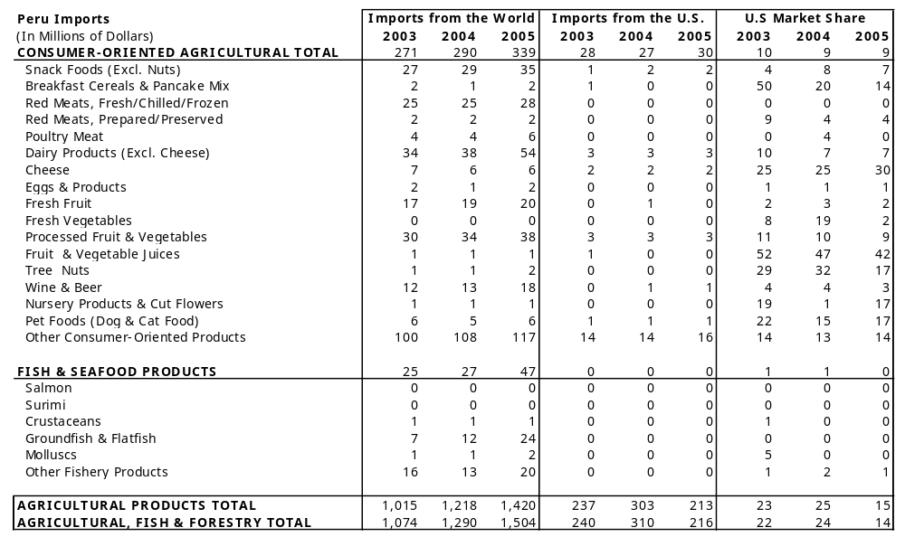
Source: World Trade Atlas (2005)

TABLE C. TOP 15 SUPPLIERS OF CONSUMER FOODS & EDIBLE FISHERY PRODUCTS
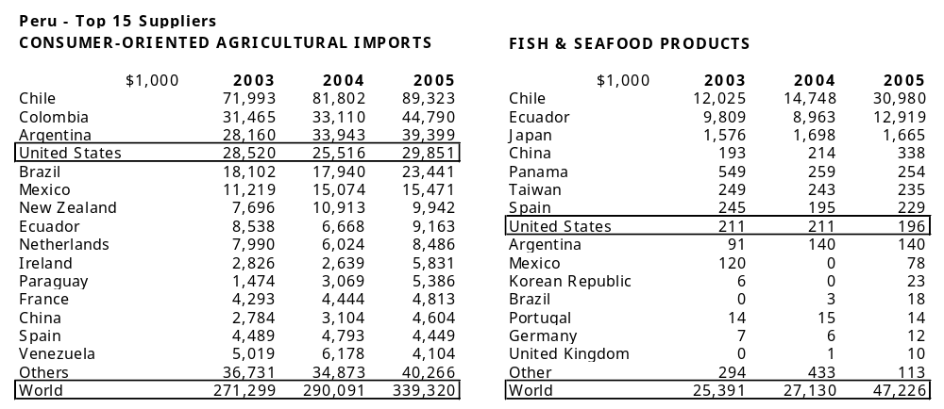

Source: World Trade Atlas (2003 – 2005)

